Distribution Router RB 3011 series
Step 1:
Default IP: 192.168.88.1 in browser
User:
Password:
Reset Router from GUI --- system – reset configuration or hardware button press

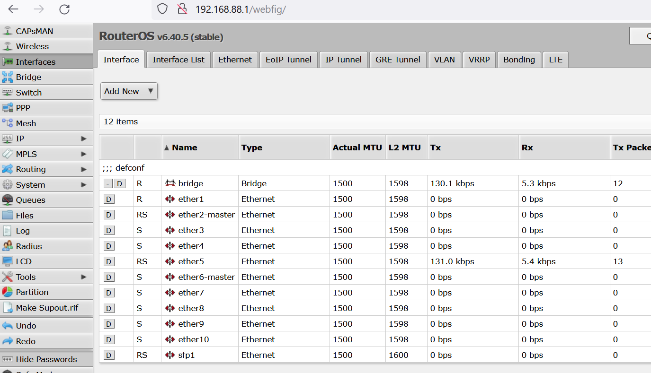

Step 2: Select interface list and change wan to SFP 1
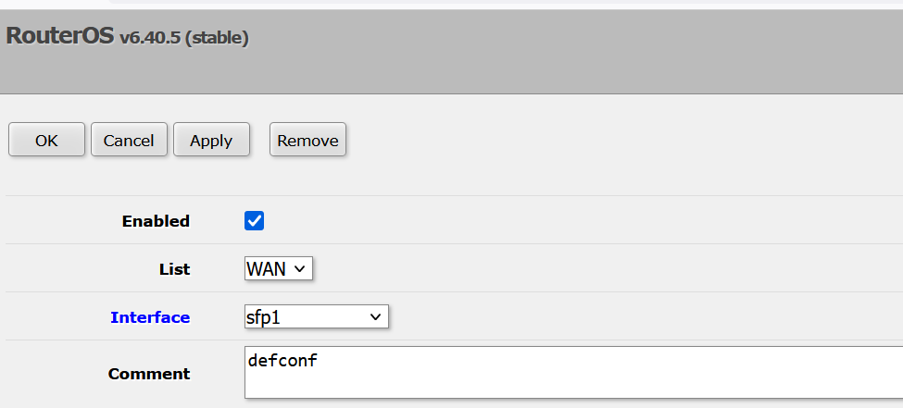
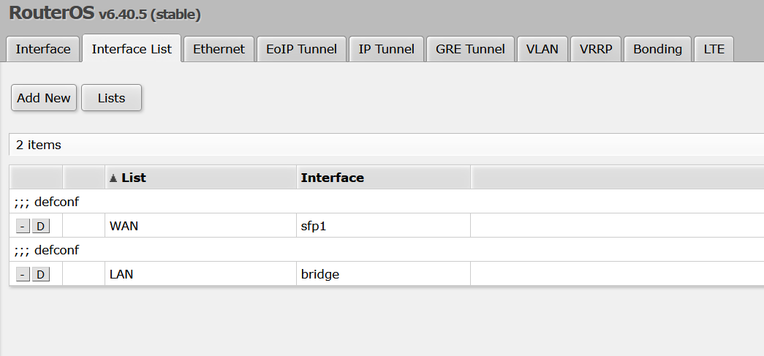
Step 3: Go to Interface and rename SFP1 to wan and eth 1 to lan
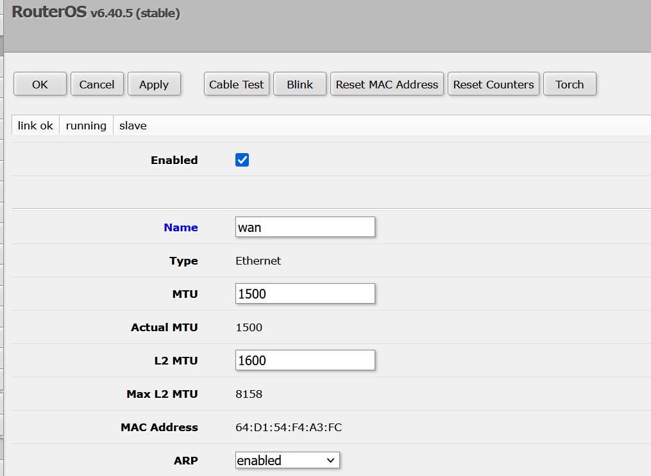

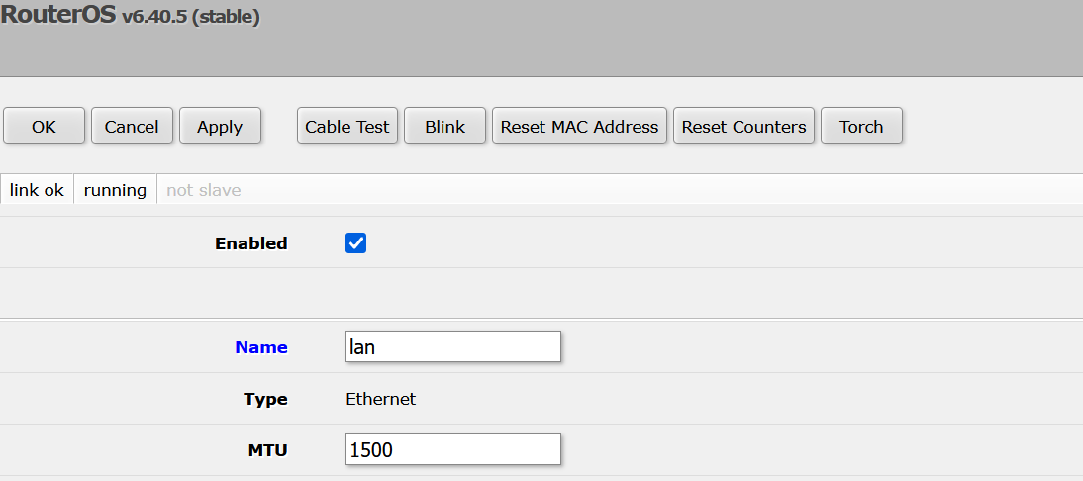

Step 4: Go to VLAN and create 3 VLAN as student, teacher and academic as 10, 20, 30
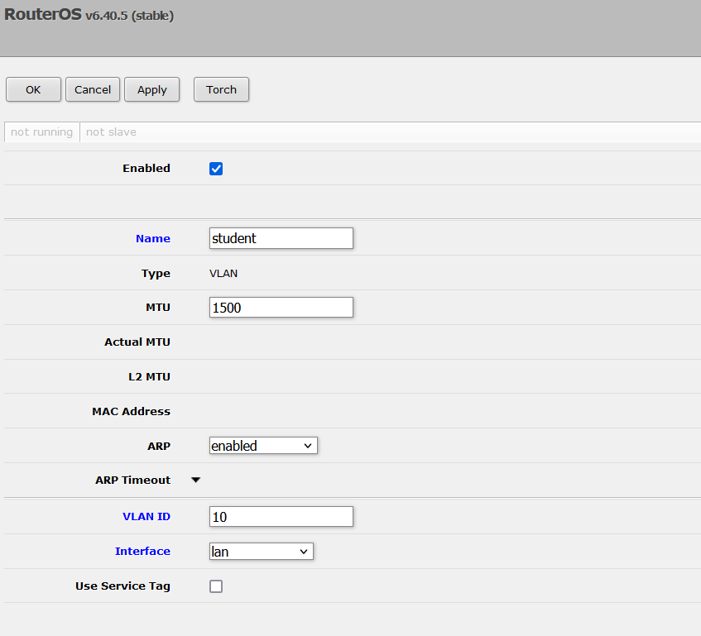
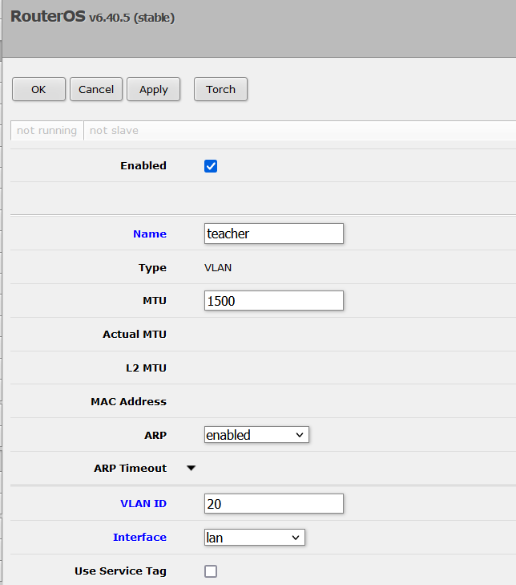
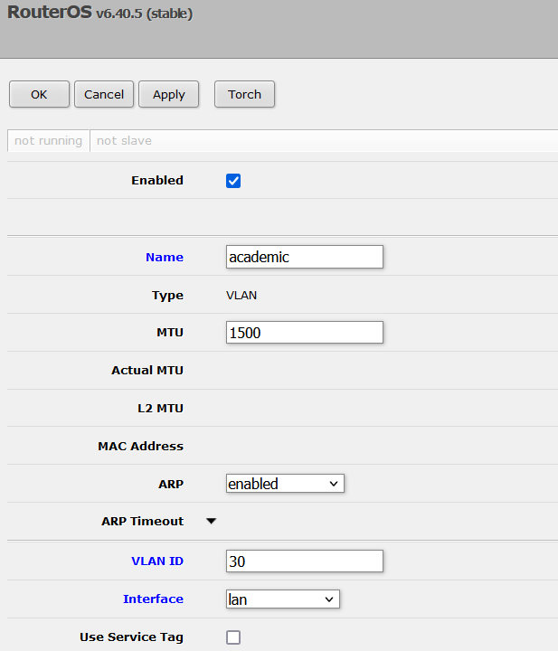

Step 5: Assign IP address go to ip address IP then add address
Distribution Router 3 | Ip address | subnet mask | Interface | Network address
GE0/0 | 10.28.88.18/29 | 255.255.255.248 | Wan | 10.28.88.16/29
GE2/0.10 | 10.28.48.1/21 | 255.255.248.0 | Lan | 10.28.48.0/21
GE2/0.20 | 10.28.72.1/22 | 255.255.252.0 | Lan | 10.28.72.0/22
GE2/0.30 | 10.28.84.1/23 | 255.255.254.0 | lan | 10.28.84.0/23

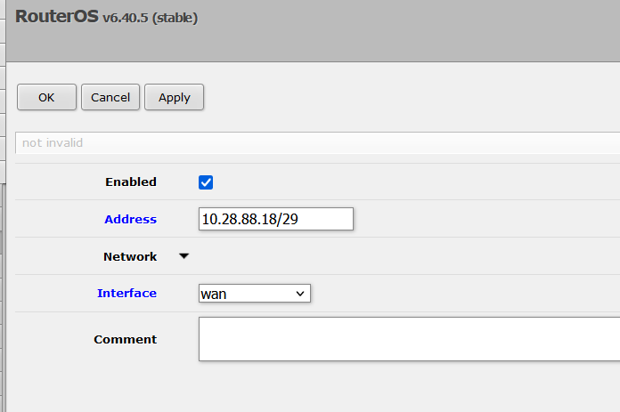
Output
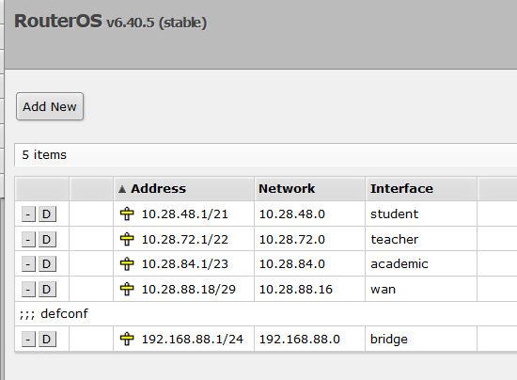

Step 6 Routing: OSPF configuration ---go to routing then select ospf
Select instances –create instances

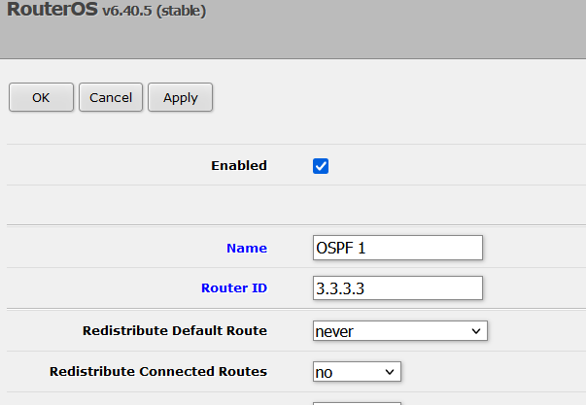
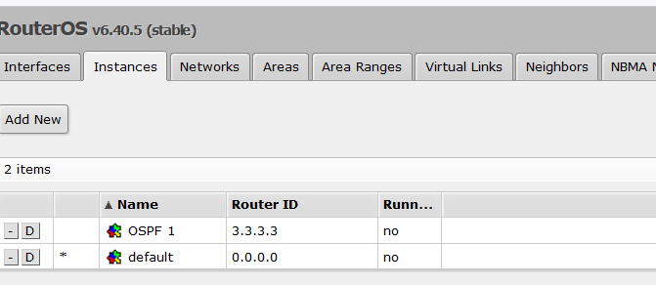
Create areas : Select areas
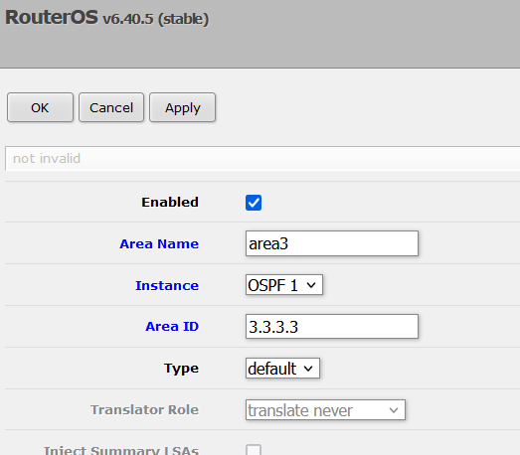
Output
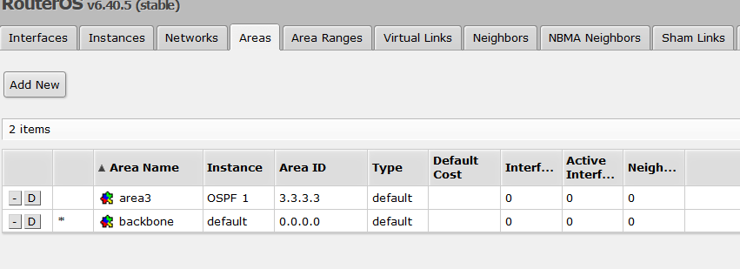
Step 7: add network in OSPF
Network address
10.28.88.16/29
10.28.48.0/21
10.28.72.0/22
10.28.84.0/23

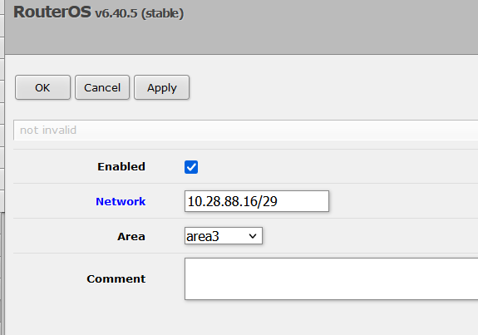
Output
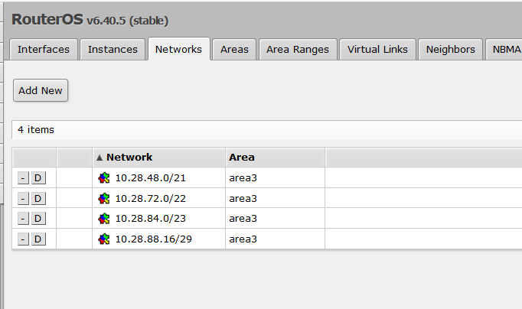

Step 8 : DHCP configuration select IP then DHCP server
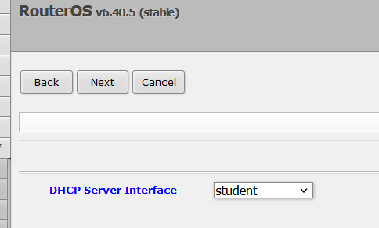
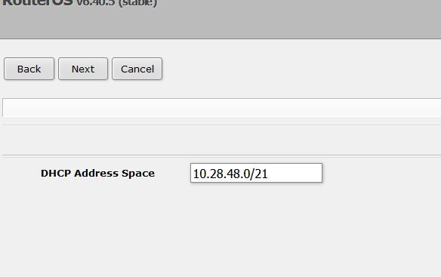
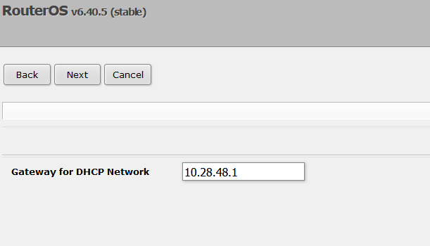
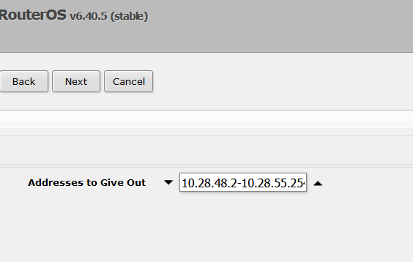
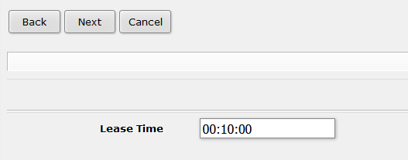

Check Routes and neighbor

